Functional Specification

Year: 2023 Semester: Spring Team: 3 Project: ”Rigged” Card Shuffler

Creation Date: Jan 17, 2023 Last Modified: Jan 21, 2023

Team Members (#1 is Team Leader):

Member 1: Zachary Williams Email: will2051@purdue.edu

Member 2: Brian Lee Email: lee3174@purdue.edu

Member 3: Dan Gue Email: dgue@purdue.edu

Member 4: Utkarsh Priyam Email: upriyam@purdue.edu

Assignment Evaluation:

| **Item** | **Score (0-5)** | **Weight** | **Points** | **Notes** |
| --- | --- | --- | --- | --- |
| **Assignment-Specific Items** | | | | |
| **Functional Description** |  | x3 |  |  |
| **Theory of Operation** |  | x3 |  |  |
| **Expected Usage Case** |  | x3 |  |  |
| **Design Constraints** |  | x3 |  |  |
| **Writing-Specific Items** | | | | |
| **Spelling and Grammar** |  | x2 |  |  |
| **Formatting and Citations** |  | x1 |  |  |
| **Figures and Graphs** |  | x2 |  |  |
| **Technical Writing Style** |  | x3 |  |  |
| **Total Score** |  | | |  |

5: Excellent 4: Good 3: Acceptable 2: Poor 1: Very Poor 0: Not attempted

General Comments:

1.0 Functional Description

Card games using a traditional 52 card playing deck remain incredibly popular today and are often played with friends, family, or even competitively. While they are very fun and provide a great source of entertainment, nearly every card game involves luck-based drawing or dealing. This can become a source of frustration and detract from the entertainment value of these card games. Components of these games that may be described as luck-based can be eliminated if a player can perform controlled shuffles that result in the exact order of cards as desired. Therefore, a device that can perform such controlled shuffles would be incredibly useful in restoring or adding to the entertainment value of such games.

The “Rigged” Card Shuffler is a device capable of accepting a standard deck of 52 cards manually inserted by the user, reading the cards, performing a controlled shuffle, and then finally outputting cards in a valid desired order. Valid desired card orders are determined by receiving a number of user inputs via an on-board interface, including but not limited to variables such as game type, the number of players, and the players (if any) that are meant to win.

2.0 Theory of Operation

Centripetal acceleration provides a key component to our project’s proper functioning. Once the cards are put into the slots for cards (see Appendix 2: Sketch of Product Prototype), they will be rotated by the stepper motor. As such, a centripetal force will be applied to the cards by the outer housing of the rotating mechanism. Because the centripetal acceleration can be represented as $a_{centripetal}=\frac{v^{2}}{r}$ [5], the centripetal force can be written as $f_{centripetal}=mass*\frac{v^{2}}{r}$. Because of the cards’ existent velocity tangent to the path of rotation and this centripetal force, there will be an apparent (but not truly existent) force away from the center of the rotation. This “centrifugal acceleration” can be represented as $a_{centrifugal}=Ω^{2}*r$ [4], and so the “centrifugal force” can be described as $f_{centrifugal}=mass*Ω^{2}*r$. It is this apparent force that is being relied on to push the cards towards the external wall and the card exit slot.

Another driving principle behind our device is the trade off between runtime and storage complexities. By temporarily binning cards in a card-specific disk, we gain fine control over specifying target card positions in the final deck arrangement without the complexity of moving platforms or slice managing algorithms. The intermediary “cache” approach trades off the logical complexity for a simpler storage complexity.

Finally, the principles of image pattern matching under rotational and scaling invariants, which underlie key image matching and recognition algorithms like OCR and SIFT, play a major role in the computer vision portion of our device. We use these principles to identify the various ranks and suits of the cards we scan by breaking down the image into a collection of visual key points, which are then used to comprehensively match the scanned card to one of the 52 potential cards.

3.0 Expected Usage Case

The “Rigged” Card Shuffler will be used as a recreational/gag product for people to use with family or friends in an indoor setting on a flat surface. Currently the assumption is that the product will function on wall power. The user interface consisting of an LCD display and a set of buttons to move through and select options should be easy to both understand and use. The assumed user is someone who understands how some card games work. The user should not need any amount of extensive technical literacy in order to operate the device. The device should be easy to operate on a mechanical level and should only require the user to input a deck into the input slot and remove the shuffled deck from the output slot. This product is meant only to be used by one person at any one time who will insert the deck, select settings and collect the shuffled deck after the product completes the shuffle.

4.0 Design Constraints

4.1 Computational Constraints

The computational side of this project falls under two main categories: the microcontroller (micro) and the RaspberryPi (RasPi).

The micro’s software does not provide any significant computational constraints. There are naturally certain hardware-derived limitations, such as maximum processor clock speed (48 MHz) and total program memory size (256 kB). However, we do not expect to develop any software that approaches or exceeds these constraints.

On the other hand, the RasPi’s software package includes several key modules, namely the critical computer vision card recognizer and the card arrangement calculator. The computer vision module will be implemented using a hybrid approach of elements from the SIFT algorithm, fusing key point analysis with more traditional brute force matching solutions. On the other hand, the card arrangement module will be based on a plethora of individual algorithms with varying use-cases: some will provide ideal sorts for guaranteeing a win in specific games, while others like Fisher-Yates (a uniform randomization algorithm) will provide arrangements for other unique use cases.

The developed software for the RasPi is also constrained by hardware specifications; however, like with the micro, we do not expect to exceed those limits. The RasPi runs with a clock speed of 1.4 GHz. Our expectation is for each of the RasPi’s software modules to complete execution within the timeframe of related hardware movement completion. For instance, the computer vision module should complete execution in less time than the hardware takes to isolate and bin a single card. These temporal execution constraints require tuning the algorithm complexities relative to the maximum computational resources available on the RasPi. Finally, the RasPi offers 1 GB of memory, which will more than suffice for all of the software modules it executes.

4.2 Electronics Constraints

As of right now, our group estimates a use of three brushless DC motors in order to control the card dispenser into the shelves. We will also need a stepper motor in order to control the bins. These will all be controlled by the microcontroller using GPIO outputs. The brushless DC motors do not need an H-Bridge or anything like that since there should be no need to change the direction of these motors. The stepper motor will be controlled using an A4988 Stepper Motor Driver using GPIO outputs. The direction of spin will be controlled by one of the GPIO outputs and the number of steps is controlled by sending electrical pulses over one of the GPIO outputs. We will also be using a button matrix that will control a menu that can be seen on an LCD screen. The button matrix will be taken as a set of GPIO inputs. The LCD screen is a TFT display that will communicate using the SPI peripheral. Lastly, the microprocessor and single board computer will communicate using a UART peripheral for bi-directional communication. Because of the planned use of acknowledgement messages, there should be no need for a buffer to keep track of previous messages on the UART communication bus.

4.3 Thermal/Power Constraints

The power constraints for our system remain fairly simple to ascertain as, for the time being, it is planned for our project to be powered via a standard wall outlet. Because such wall outlets in the United States usually supply a voltage ranging from 110 V to 120 V [4] such a range represents the upper limit. However, this is unlikely to be an issue if the device remains wall-powered as all components, including the microcontroller, the single-board computer, and motors should not necessitate more than 120 V cumulatively.

Furthermore, as there will be inductive loads in the form of motors, arc suppression diodes or other measures to prevent inductive kickback must be included to protect the device with which the motors are switched.

It is also critical that temperature sensitive components such as the microcontroller, single-board computer, and LCD screen are not exposed to excessively high temperatures. Proper component spacing and heat management are therefore critical, especially within the context of an expected device up-time of several hours at a time.

4.4 Mechanical Constraints

Because this is a product that is meant to be used in a home entertainment context, and because it contains motors and fast moving parts, a mechanical factor that must be considered is that moving parts should not be exposed, lest a user’s appendage come in contact with a fast moving part suffer undue harm. Furthermore, the materials from which the case of the product is created should be able to withstand the forces from the fast moving internal parts such that the device does not collapse upon itself.

As the device is meant to be used by one user, it must be light enough such that the user can move it around without risk of injury. With this constraint in mind, a total product weight under 50 pounds must be achieved.

Because this device is intended to be used indoors on a flat surface and is not intended to withstand exposure to water, wind, or other extreme conditions that may be experienced outdoors, the case of the product does not need to be weatherproof, nor does it need to withstand external shocks.

4.5 Economic Constraints

There is a very large range of prices for card shufflers on the market ranging anywhere from around $20 [1] for a very low end shuffler to somewhere close to $700 [2] for a high end card shuffler. Because the product is a gag item, we should attempt to stay near the middle of the road for card shufflers. Our goal is to keep the cost of the product somewhere below $350 to keep it cheaper than the high end shufflers while allowing for more features. Currently we have not found any kind of direct competition for a gag Rigged Card Shuffler on the market.

4.6 Other Constraints

Because the product can be used to control shuffles for card games, some of which may be the same games used in gambling contexts, it is imperative that the product cannot be used for cheating purposes, lest the distributors of the product draw the ire of gaming control boards or other regulatory agencies with an interest in fairness in gaming, gambling, or general consumer protection. For this reason, the device must clearly indicate when it is performing a controlled shuffle, as opposed to when it is performing a fair shuffle.

As the “Rigged” Card Shuffler is intended for tabletop use in close proximity to the user, device shaking should be kept to a minimum such that the device does not seem violent in operation. Furthermore, the volume of device operation should be kept to a safe level, and so sound pressure level should be limited to 70 dB at a distance of 1 foot from the device.

Lastly, because the intended use is for the device to mimic an actual card shuffler, the device should perform controlled shuffles in a fairly reasonable amount of time, such as within 10 minutes.

5.0 Sources Cited:

[1] “Amazon.com: Nileole 1-2 decks automatic card shuffler, battery-operated ...,” *Amazon*. [Online]. Available: https://www.amazon.com/Nileole-Automatic-Shuffler-Battery-Operated-Blackjack/dp/B09MJWFQ5X. [Accessed: 21-Jan-2023].

[2] “Buy shuffle tech automatic card shuffler w/ free shipping,” *Gaming Blaze*. [Online]. Available: https://www.gamingblaze.com/products/shuffle-tech-st1000-automatic-card-shuffler?currency=USD&variant=15804104147001&utm_medium=cpc&utm_source=google&utm_campaign=Google+Shopping. [Accessed: 21-Jan-2023].

[3] “Centrifugal Force,” Centrifugal Force - an overview | ScienceDirect Topics. [Online]. Available: https://www.sciencedirect.com/topics/earth-and-planetary-sciences/centrifugal-force. [Accessed: 21-Jan-2023].

[4] J. Bennett, “The 5 essential outlet tests every homeowner should know how to do,” *Better Homes & Gardens*, 21-Aug-2022. [Online]. Available: https://www.bhg.com/home-improvement/electrical/how-to-test-an-electrical-receptacle. [Accessed: 21-Jan-2023].

[5] P. P. Urone and R. Hinrichs, “6.2 Centripetal Acceleration,” College Physics. [Online]. Available: https://pressbooks.online.ucf.edu/algphysics/chapter/centripetal-acceleration/. [Accessed: 21-Jan-2023].

**Appendix 1: Functional Block Diagram**

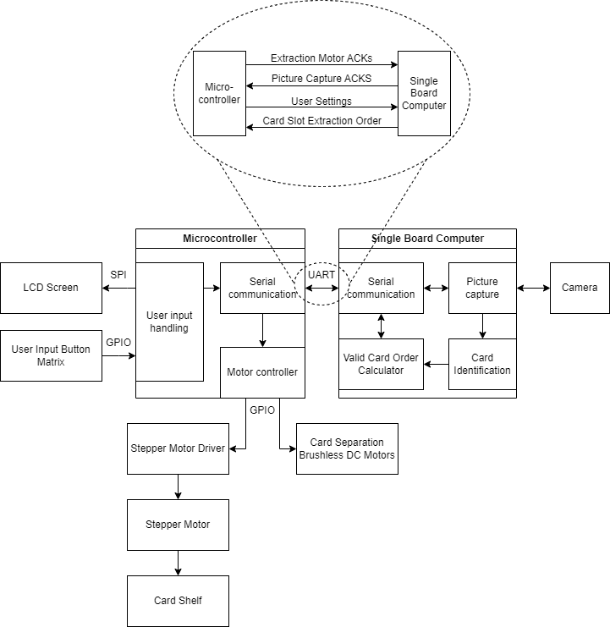

**Appendix 2: Sketch of Project Prototype**

